How to Help Yourself  Tell someone who can help.  - If you can’t talk to parents, find a friend, school psychologist, school counselor, coach or call a community help line or the National Suicide Prevention Lifeline.  - Don’t be ashamed or embarrassed—many teens have problems they can’t solve on their own.  - Finding the courage to get help is the first step.  Who Can Help?  Help is available anytime, anywhere.  - National Suicide Prevention Lifeline—a free, 24-hour hotline available to anyone in suicidal crisis or emotional distress or anyone concerned that someone they care about might be in crisis. 1-800-273-TALK  - North Key Community Care Community Crisis Lines—a free, 24-hour local NKY agency crisis hotline. 1-877-331-3292  - The Brooks Hospital—a free, 24-hour local NKY agency crisis line to receive help from licensed mental health professionals 800-866-8876 or 866037306085  - SUN Behavioral Health—a free, 24-hour local NKY agency, phone call 859-340-8858 or telehealth consultation (https://sunbehavioral.com/kentucky/telehealth-consultation/)  - Crisis Text Line— a free, 24-hour anonymous US based agency, Text Home to 741741  How to Help a Friend in Need  - Listen to a friend with concern and feeling—just talking to a friend and letting them know they are not alone can make a big difference.  - Be especially concerned if someone tells you they have made detailed suicide plans and/or obtained a means of hurting themselves.  - If you find a friend in crisis, find a responsible adult who can help—teachers, school counselors, school psychologists or other school staff.  - If you suspect a friends is in crisis, tell someone immediately—even if you’re unsure they are serious.  Use the LIFE Model  (from The Jason Foundation)  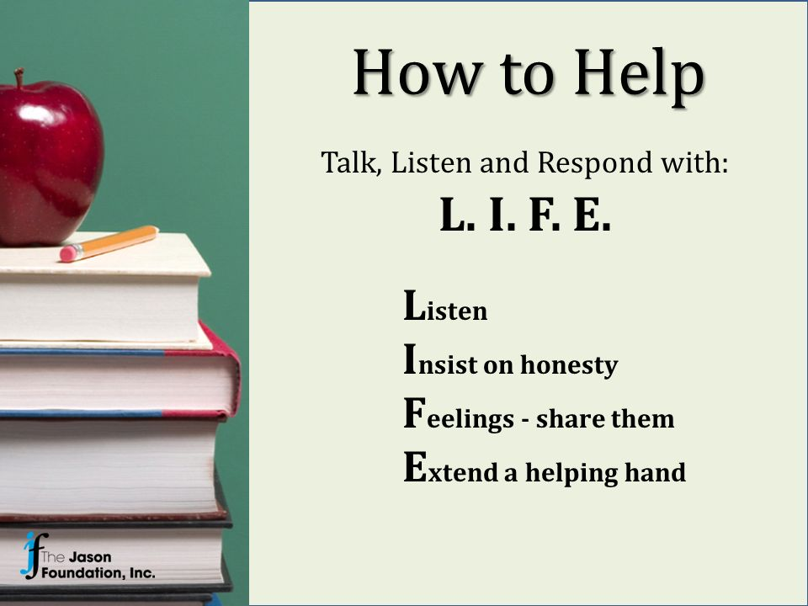 | Resources for Teens  - National Institute of Mental Health https://www.nimh.nih.gov/index.shtml  - National Suicide Prevention Lifeline https://suicidepreventionlifeline.org/  - American Association of Suicidology https://suicidology.org/  - National Association of School Psychologists https://nasponline.org/suicideprevention  References  www.sprc.org-featured_resources/customized/teens.asp  www.suicidepreventionlifeline.org  www.jasonfoundation.com  Suicide Prevention and Intervention by Lieberman, Poland, and Cowan (2006)  *Adapted from Boone County School Psychologists Brochure  Suicide Warning Signs for a Friend in Crisis  - Verbal and written statements about death and dying  - Threatening to hurt or kill oneself  - Feeling hopeless; Feeling trapped like there's no way out  - Feeling of rage or uncontrolled anger  - Acting reckless or engaging in risky behavior  - Dramatic changes in behavior  - Mood swings or sudden change in personality  - Fascination with death and dying  - Giving away prized possessions or making out a will  - Worsening school performance  - Withdrawal from family and friends  - Neglecting appearance  - Increasing alcohol and drug use  - Feeling anxious or agitated  - Increase/Decrease in sleep  - Seeing no reason to live | Suicide Prevention Resource for Teens  Possible Triggers  Possible events that may trigger a friend to talk or think about suicide:  - Getting into trouble with authorities  - Breakup with a boyfriend or girlfriend  - Death of a loved one or significant personal loss  - Knowing someone who died by suicide  - Bullying or victimization  - Family conflict or dysfunction  - Academic crisis or school failure  - Disappointment or rejection  - Abuse or trauma  - Separation from family and friends

